 | Jam Jar Solar Instructions

Date: | 04/12/2020 | Version: | 1.0 | By: | Matt Little

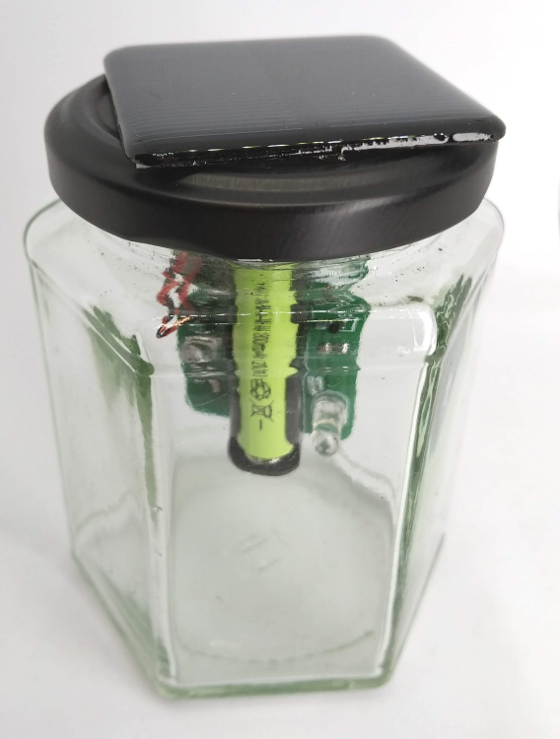  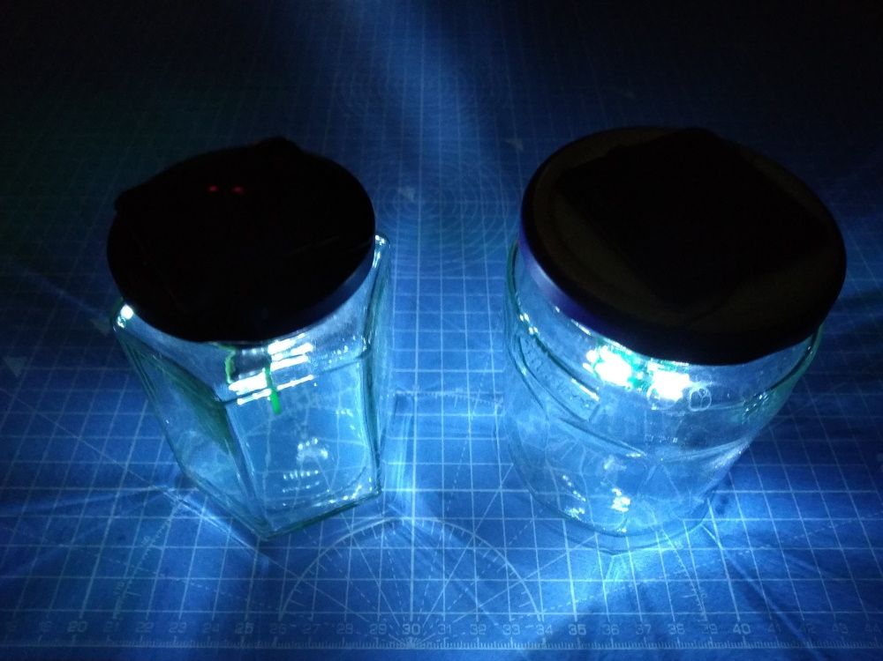 | Convert an old jam jar into an outdoor solar powered night light!  This relatively simple DIY soldering kit has all the parts you need to make a bright solar-recharged night light.  We have designed this with hardware to fit nicely into a jam jar, but it could be used in other enclosures.  It is based on the QX5252 solar lamp IC, which takes care of charging a nickel metal hydride (NiMH) cell from a small solar panel. It also uses the solar panel output voltage to control when the light switches on. It is also a step-up converter to supply the correct current and voltage to the LEDs, so we can drive four white LEDs from just a single NiMH cell.  This is a relatively simple soldering kit, suitable for beginners, which should take in the region of 1 hour to build.  Note: Jam jar not supplied!!
The github repository for PCB files & schematics, along with the enclosure files and these instructions, is available here: https://github.com/curiouselectric/jamjarsolar

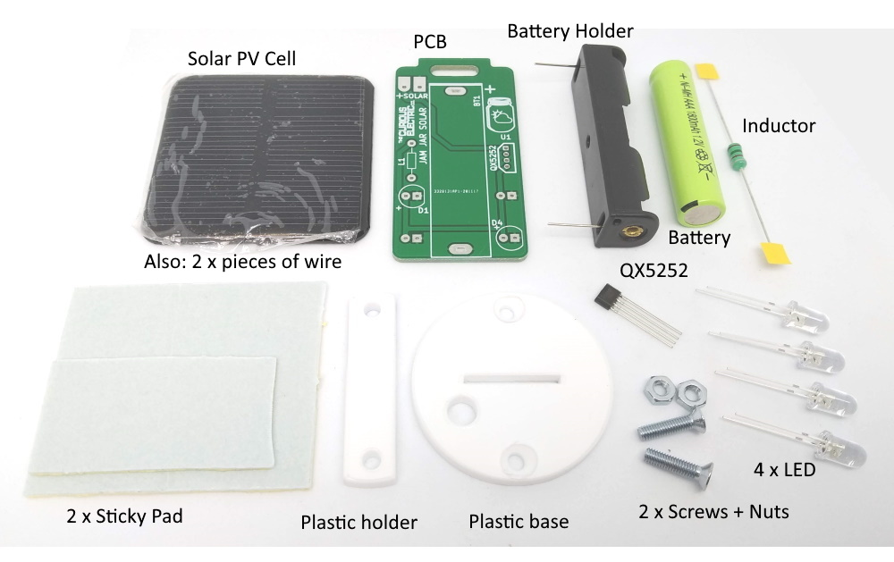
Parts included:

Parts list:
Ref | Item | Quant | Ref | Item | Quant
 | 1 x Nickel Metal Hydride 1.2V AAA Battery | 1 |  | M3 12mm Machine screws | 2
BT1 | 1 x AAA Battery Holder | 1 |  | M3 Nuts | 2
D1-D4 | 5mm LED White | 4 |  | Circular Base Plate – 3mm Acrylic | 1
L1 | 150uH Inductor | 1 |  | PCB Holder – 3mm Acrylic | 1
U1 | QX5252 Solar Charger IC |  |  | Sticky Pad | 2
 | Solar Photovoltaic Panel. 2V 160mA | 1
 | Cable – Red/Black 50mm | 2

Tools required:
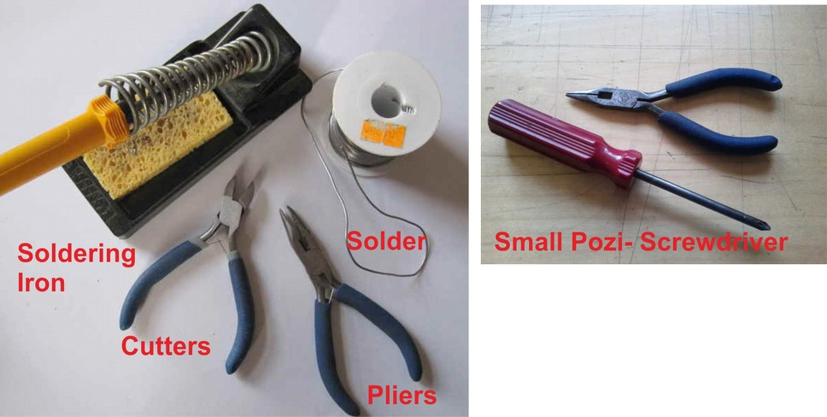

Build Instructions:
Step: 1 | Solder Inductor
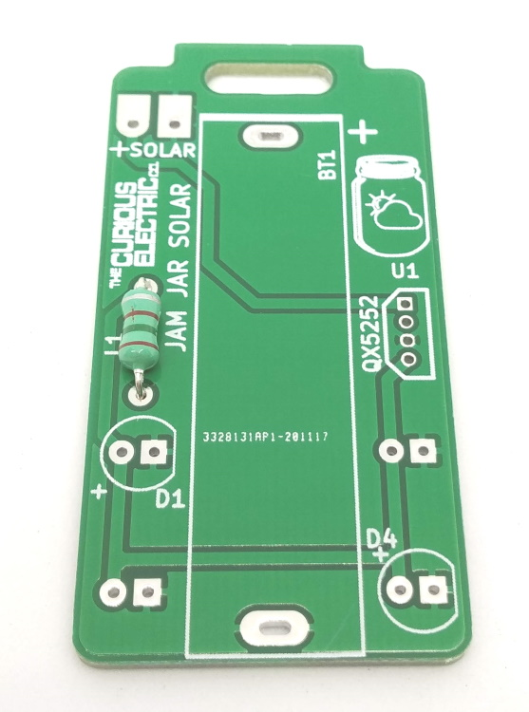 |  | Place the inductor L1 into the holes on the PCB.  Solder in place.  Orientation of this component does not matter.

Step: 2 | Solder QX5252
Solder in the QX5252 4-pin integrated circuit (IC) into the area marked U1.  Ensure the component orientation matches the silk screen diagram – the cut-off edges should match the silk-screen image on the PCB.  Carefully solder all four legs. |  | 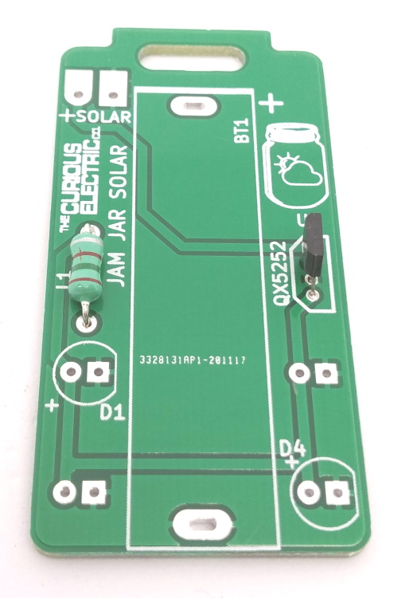

Step: 3 | Solder LEDs
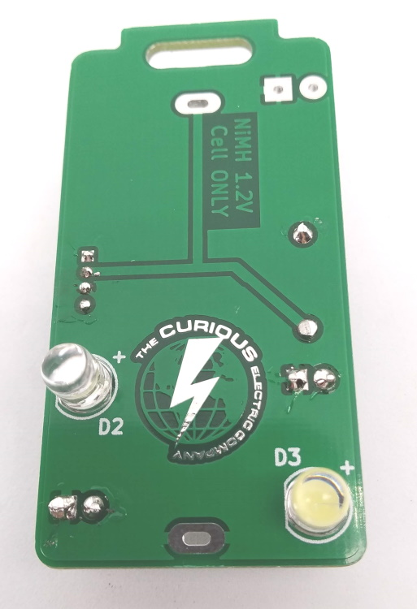  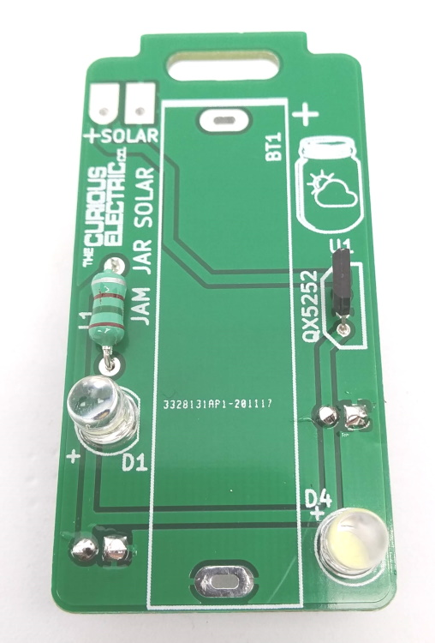 |  | Insert LEDs D1 and D4 from the front of the PCB.  Ensure the correct orientation. The longer lead of the component is the +ve and should go into the hole marked +.  Insert LEDs D2 and D3 from the BACK of the PCB. These shine in the other direction!  Again – ensure correct orientation.

Step: 4 | Solder Battery Holder
Insert the battery holder from the top of the PCB into the area marked BT1.  Ensure the + of the battery holder aligns with the + symbol on the PCB (at the ‘top’ of the PCB near the large hole). |  | 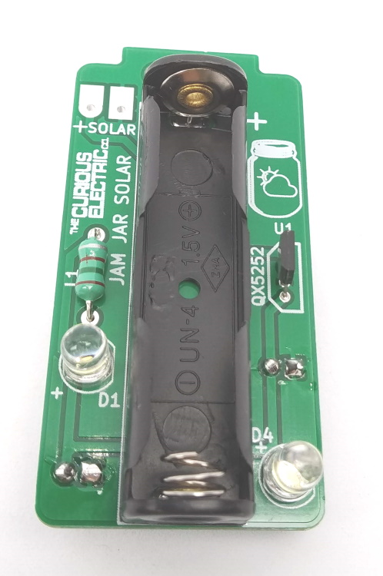

Step: 5 | Add cable to Solar PV Cell
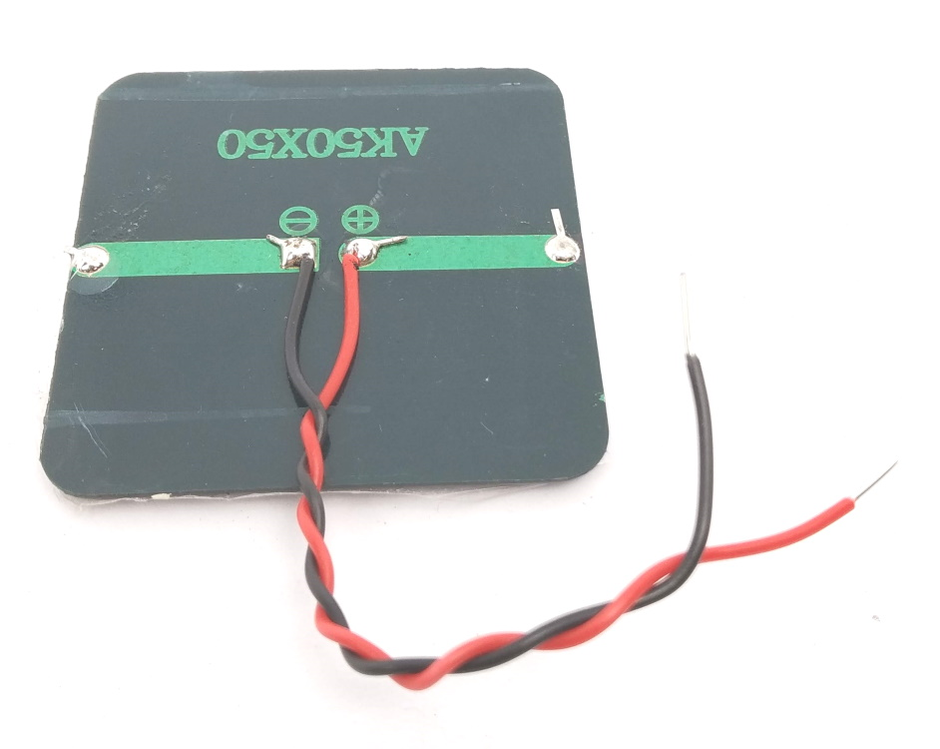 |  | Using the two pieces of wire, carefully strip both ends of the cable.  Solder the red cable to the +ve on the solar photovoltaic cell.  Solder the black cable to the -ve on the solar photovoltaic cell.  Give the wires a little twist to keep the two ends together.

Step: 6 | Hold PCB onto base plate
Using the two plastic pieces and the two M3 screws and nuts.  Peel off the protective plastic sheet from both sides of the two plastic pieces.  You need to place the PCB into the slot on the round plastic base. Ensure the countersunk holes are away from the PCB.  Push the rectangular plastic holder through the slot in the PCB.  Align the two holes.  Put the two screws through the plastic, ensuring the screws go through and the heads are countersunk.  Add the two nuts and tighten. |  | 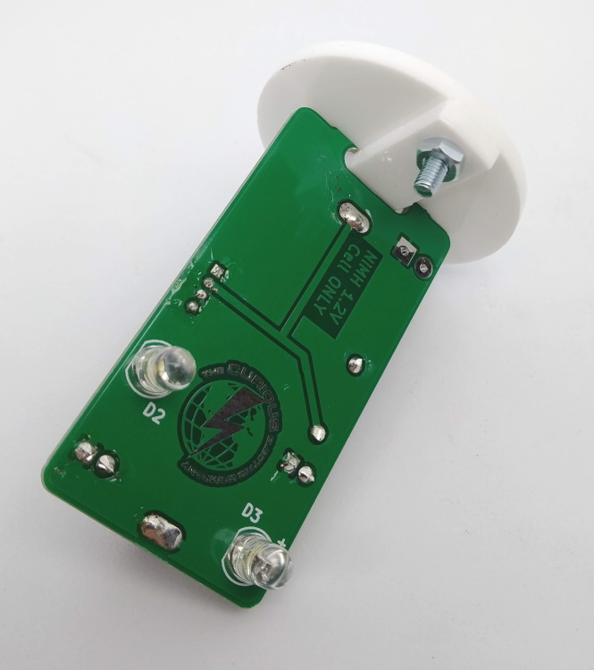  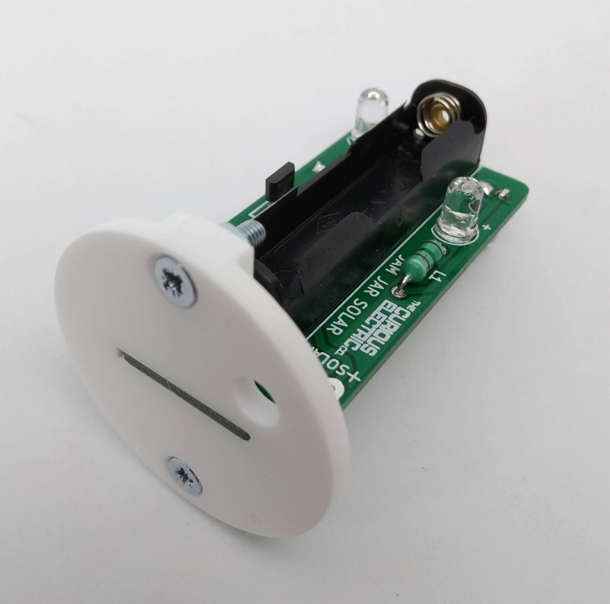  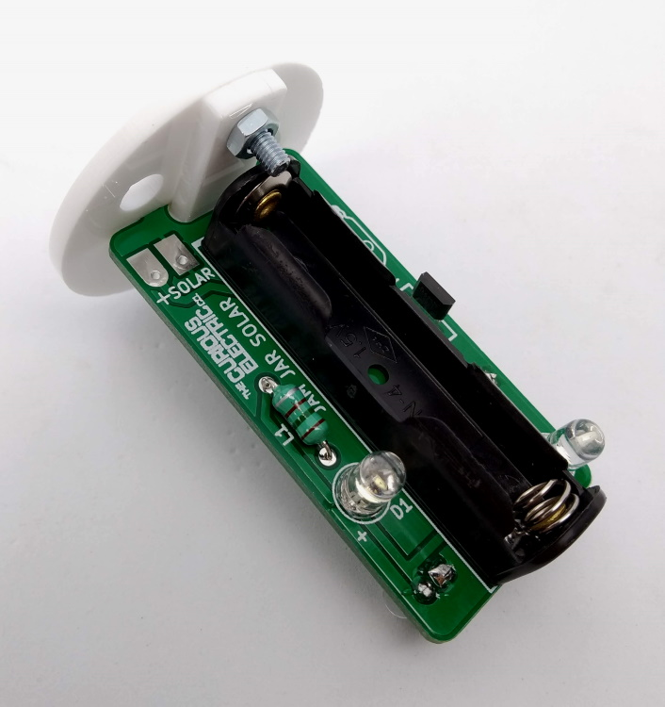

Step: 7 | Put hole in jam jar lid
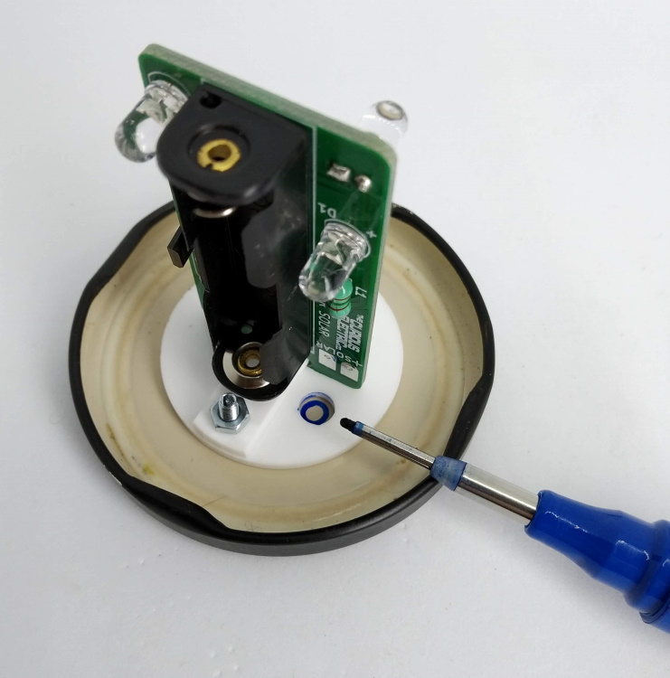 |  | Note: Ask an adult to help you with this stage!  Using the plastic base as a template, mark the hole for the solar cables to go from the top of the jar lid into the jar. This should be the only hole you need to make.  You can either use a large nail and hammer through onto a piece of wood to make the hole.  Or you can use a drill to make this hole.  Be very careful with the sharp edges there might be. File these down.

Step: 8 | Fit Solar Panel to jam jar lid
Place the solar cell onto the jam jar lid and align the cables through the hole you have just made.  Use the large sticky pad to hold the solar cell in place.  You may need to cut this to size.  You may also want to use some sealant or hot-melt glue to seal around the cable entry to stop any moisture getting in. |  | 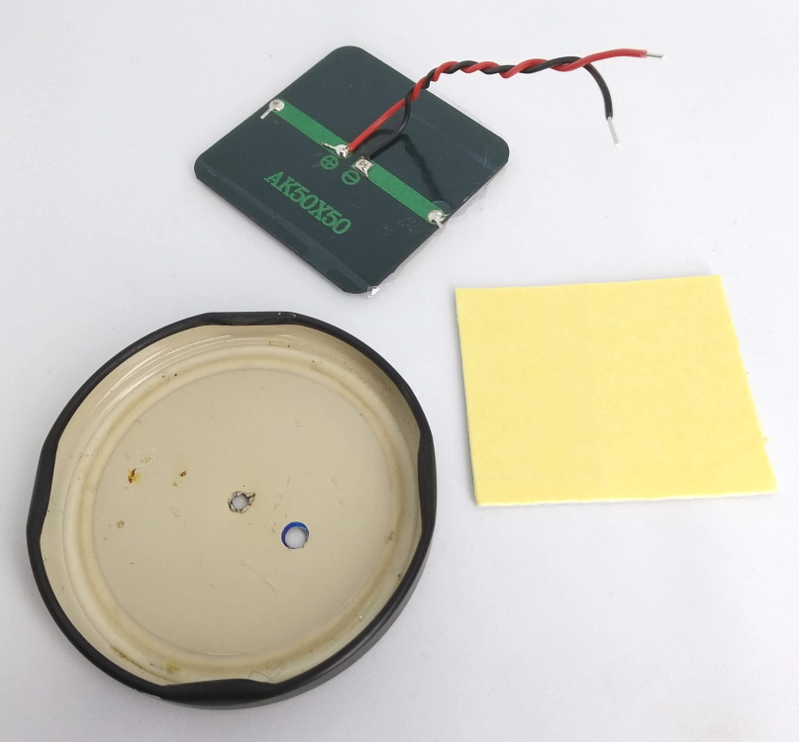  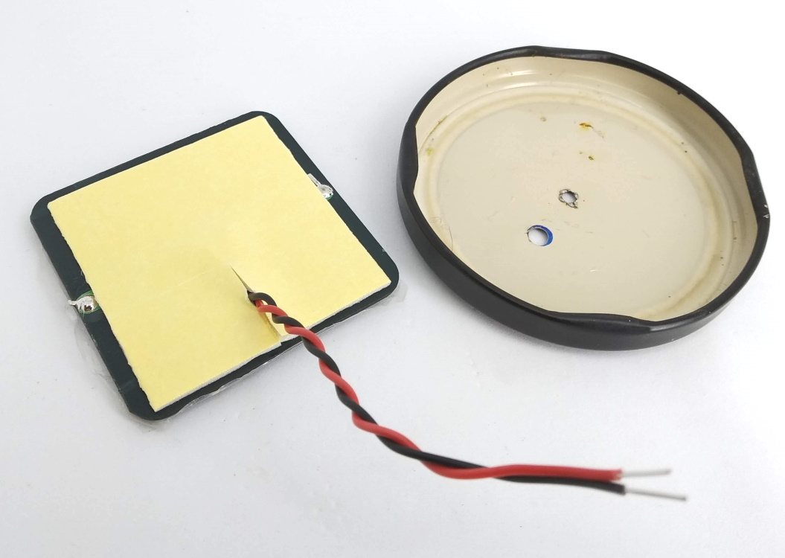  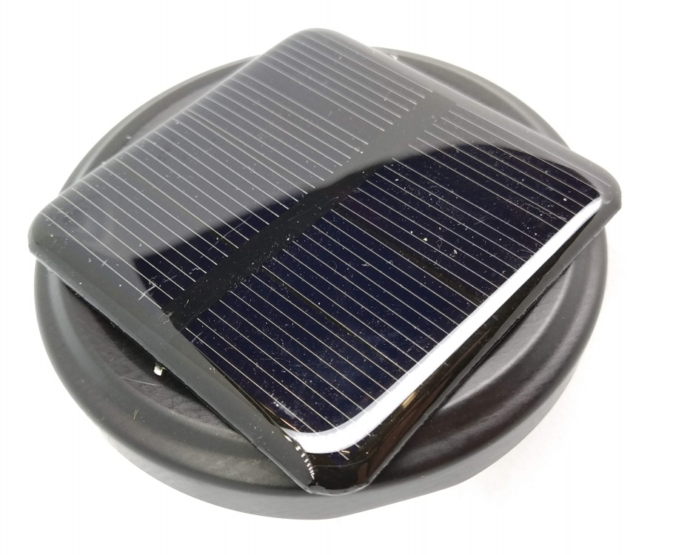

Step: 9 | Fit solar cell cable through and solder
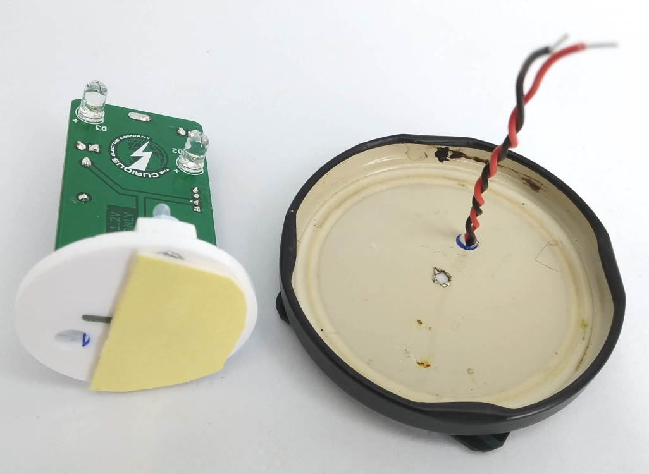  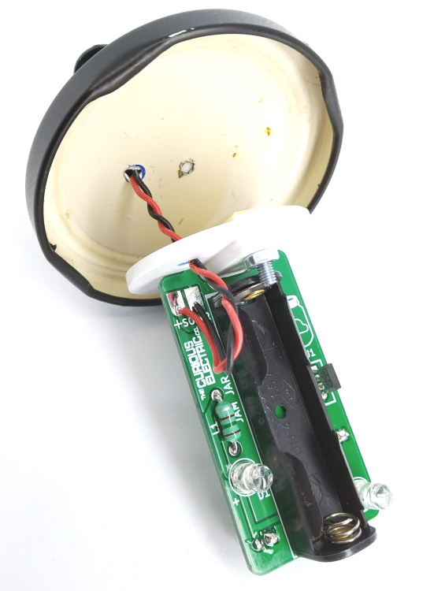 |  | With the cable through the jam jar lid, solder the red +ve cable to the pad marked with a + on the ‘Solar’ connections.  Solder the black cable onto the other (square) pad.

Step: 10 | Fit PCB to lid and add battery
Using the other sticky pad, stick the plastic base plate to the underside of the jam jar lid.  You may need to cut the sticky pad to size.  Insert the AAA NiMH battery into the battery holder, ensuring you observe the polarity. The +ve of the battery should got into the + of the battery holder. |  | 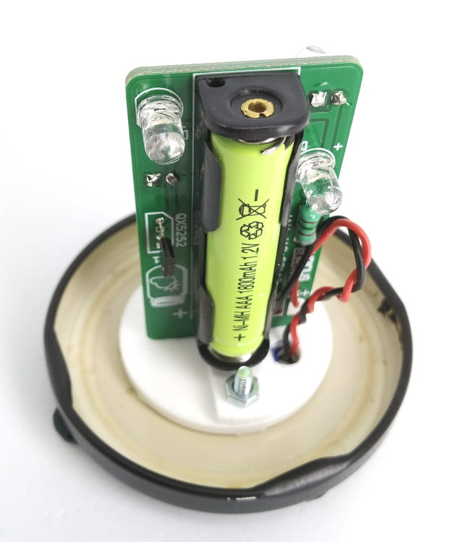  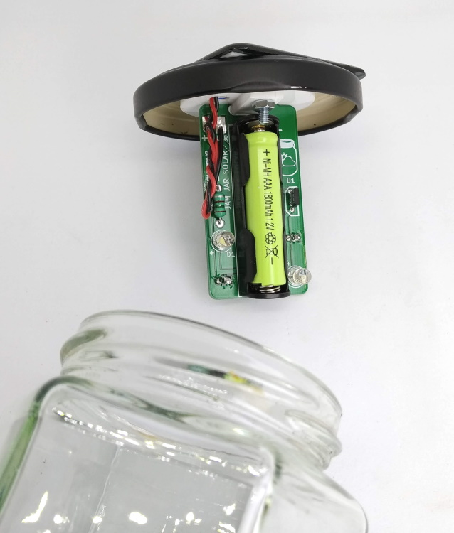

Step: 11 | Complete! Leave in sun to recharge
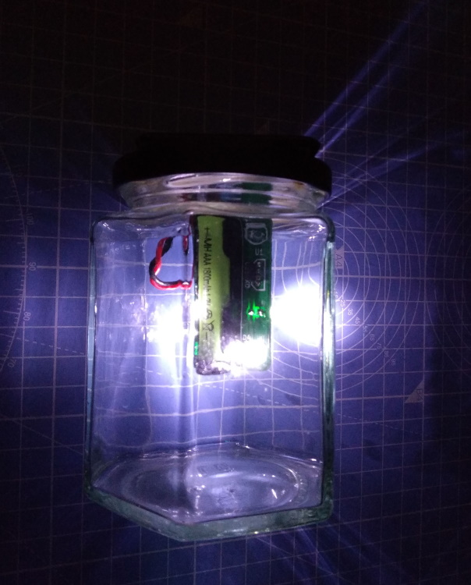 |  | The NiMH battery will probably arrive discharged.  Leave your unit in the sun for at least a day.  To test, fully cover the solar cell and the LEDs inside the jam jar should switch on.  Or wait until night time when it will automatically switch on!

Contact Details:
We would like you to be happy with this kit. If you are not happy for any reason, then please contact us and we will help to sort it out.
Please email hello@curiouselectric.co.uk with any questions or comments.
Please tweet us at @curiouselectric
If any parts are missing from your kit then please email hello@curiouselectric.co.uk with details and, if possible, where the kit was purchased.
More technical information can be found via www.curiouselectric.co.uk

This kit has been designed and produced by:
The Curious Electric Company
hello@curiouselectric.co.uk
www.curiouselectric.co.uk
Unit 23, Block D, Hartley Business Centre,
Haydn Rd, Nottingham, NG5 1DG, UK

Schematic
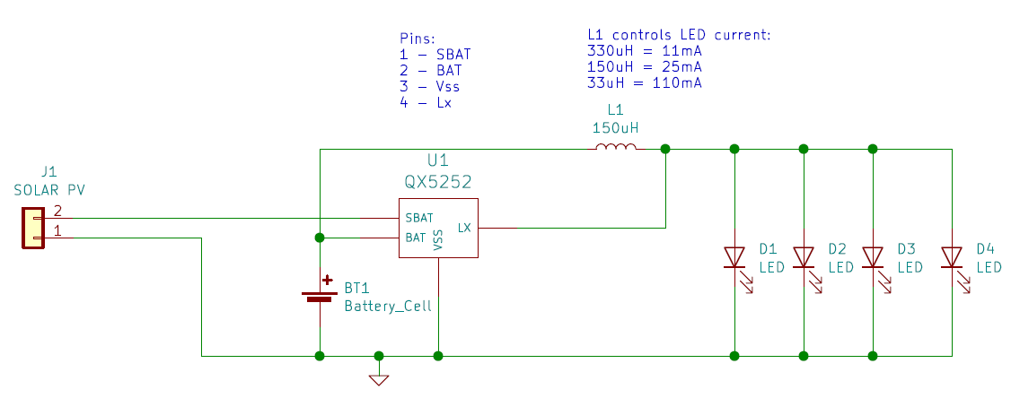

PCB
